Input Contribution

Title: | Categorizing the Elements of Web Services | Public OMA Confidential
To: | MWS
Source: | David Turner  +1 425 706 9459  dturner@microsoft.com
Attachments: | n/a | Public OMA Confidential
Replaces: | n/a
- Reason for Contribution
The goal of this document is to help improve the understanding of the different parts of Web services and how they apply to the creation of mobile-services, OMA-defined service enablers, other internal system components, and third party or external resources.
- Summary of Contribution
This document introduces the notion of four categories that can be used to better understand the relationships between Web services specifications and how those specifications are used within the various elements of an OMA solution.
- Detailed Proposal
  - Definitions
Within OMA the term “service enabler” is used as the name of a formal document publication as defined in the OMA Process Document (e.g., Mobile Location Protocol Enabler Release) and as a name for any system components that implement said publications (e.g. a location enabler).
For the purposes of this document I will use the following definition for Service Enabler (SE) [1]:
A technology intended for use in the development, deployment or operation of a Service; defined in a specification, or group of specifications, published as a package by OMA.
The term “service” has also been the source of much confusion and misunderstanding. Within OMA, “Service” is usually assumed to mean [1]:
A resource or facility provided by a service provider to their "users" (possibly for a fee). A "user" is any consumer of the Service outside the domain of the service provider. A Service may make use of zero or more enablers and may incorporate other technologies.
However, within the IT industry, “service” typically means [3]:
A software object that is a component of a system capable of performing a task, meant to interact with other components, encapsulating certain functionality or a set of functionalities. It has clearly defined interfaces and conforms to a prescribed behaviour common to all components within an architecture.
This paper is primarily about the infrastructure used to build mobile solutions rather than the solutions themselves. So to avoid confusion, this document will use “service” as a generic term referring to a system component. The term “mobile-service” will be used to refer to the OMA definition.
  - Messaging
The MWS Overview [2] describes a service-oriented architecture (SOA) as, “the interaction between a service and its consumer…based on conversational, message-based interactions.” And that, “Web services was defined from the ground up to address loosely coupled, service-oriented architectures”. To that end, the goal of Web services is to provide a general purpose messaging framework that can be secure, reliable and transacted.
    - Message-based interfaces
A message-based interface has a number of key characteristics:
- The interface is defined by contracts and constrained by policies.
Note: The expression of contracts and policies (paper or electronic), how they are discovered and exchanged (manually or in some automated way) and the extent to which one trusts those contracts and policies are important but out of scope of this document.
- There is a distinct separation between the expression of a contract and the implementation of a contract; between the expression of a policy and the enforcement of a policy.
- An interface (of any type) is distinct from the code that implements the logic.
- A new version of an interface is a new contract.
- A new implementation of the service logic does not create a new contract if the service interface does not change.
- The same logic can be exposed via multiple interfaces. This makes it easier to have different interfaces for different QoS (for example), to enable side-by-side versioning and to make a service available via multiple programming languages.
- The complete definition of a service comprises all of its interfaces, however, that does not mean all interfaces will be exposed to all users.
- The type of interface between the message-based interface and the service logic doesn’t matter to the consumer of the service. For example, they could be loosely coupled as shown by Message-based interface 1, or tightly coupled as shown by Message-based interface 2 (see Figure 1).

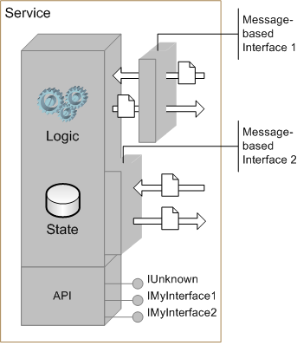
Figure 1: Service with multiple interfaces
  - Categorizing Web Services Specifications
There are many parts to Web services and there have been significant discussions about how to label the various components, without achieving any consensus. So rather than focus on naming, I propose the following four categories where each is defined by the primary characteristics of what is in those categories.
    - Category 1
Those specifications that define or describe basic message construction. This includes SOAP, XML Schema and WSDL. Or put another way, what is covered by the WS-I Basic Profile [4], not including UDDI [5].
    - Category 2
Those specifications that define header construction or the structure of specific headers but not necessarily the content of those headers. Their semantics are primarily extensions to basic message construction, for example, WSS-SOAPMessageSecurity [6], WS-Policy [7], etc.
    - Category 3
Those specifications that define the structure and content of headers and include changes to the basic protocol (e.g., restrictions or specific message exchange patterns). WS-ReliableMessaging [8]and WS-Transaction [9] are good examples for this category. Specifications in this category frequently make use of specifications from Category 2 or contain header definitions of the same type as those in Category 2.
    - Category 4
Those specifications that define a specific application. That is, they define specific messages, with specific message content (often in the body of the message), that follow specific exchange patterns. Examples for this category include UDDI, Network ID and XKMS [10].
The elements of Category 1, 2 and 3 are the building blocks for defining the “conversational, message-based interactions” [2] of Web services. They define the invocation aspects of a service. The specifications in Category 4 generally address very specific aspects of the system and are more closely associated with the configuration and control of services than the delivery of services.
  - Sample Scenarios
The following scenarios are provided to help illustrate how specifications from the above categories would be applied in the context of OMA.
The examples focus on the runtime aspects of various services. It is assumed that service registration and discovery (e.g. via UDDI), service binding (e.g. via WSDL), and the acquisition and management of any necessary security tokens or other policies have already taken place.
As Web services mature, service models will evolve from using simple point-to-point interactions as is the norm today, to services based on message paths and policy-based routing. However, to maintain consistency with the Phase 1 goals of the OWSER these examples all use point-to-point interactions.
To simplify the diagrams only the request are shown. Response messages (if any) are implied.
    - Legend
Green base
- Represents the domain of the service provider.
Arrows
- Red – Initial request (may or may not be a Web service message)
- Blue – OMA Web service message
- Green – non-OMA Web service message (or other non-OMA interface)
System Blocks
- Grey – Service Enabler (i.e., implements one or more OMA Service Enablers)
- Orange – Other application or resource (i.e., does not implement any OMA Service Enablers)
- Transparent – resources not used or required in the example
- Gold – external or 3rd party entities (may or may not use OMA Service Enablers)
    - Scenario-1 – Purchase ring tone
Customer uses operator provided mobile-service to purchase a new ring tone. The user chooses a ring tone and initiates the purchase. It is assumed that the subscriber has already been authenticated on the operator’s network. See Figure 2 Figure 2below.

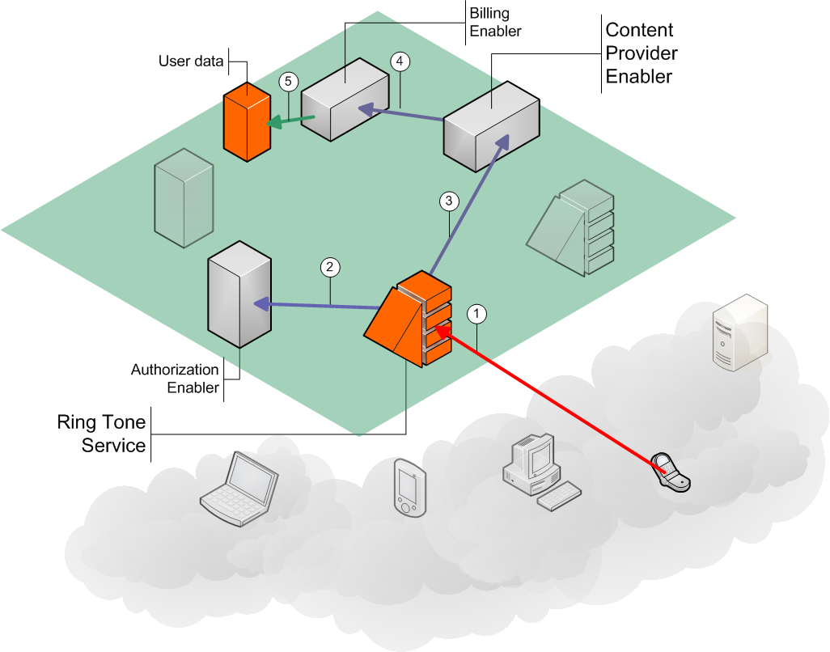
Figure 2: Purchase ring tone

- The client app sends a message to the operator’s Ring Tone Service to initiate the purchase.
- The Ring Tone Service sends a message to the Authorization enabler to determine whether this account is allowed to purchase a ring tone.
- The Ring Tone Service sends a message to the Content Provider enabler indicating which ring tone is being purchased and by whom.
- The Content Provider enabler sends a message to the Billing enabler.
- The Billing enabler sends a message to update the user’s account data.
The specific interface of the Ring Tone Service (via the red arrow) is unique to the service provider, although it may make use of some OMA enablers. In this, and the other scenarios, the essential structure and form of all blue lines are defined using Category 1. The specific interfaces, messages and message patterns for the Authorization, Billing and Content Provider enablers are defined using specifications from Category 1, 2 and 3. The Authorization enabler as a whole acts as a control function of the service making it a member of Category 4. Since the User data system is unique to this service provider, the communication between it and the Billing enabler (the green arrow) is not defined by OMA and might not use any Web services specifications.
    - Scenario-2a – Find nearest ATM
Customer uses operator provided mobile-service to find the nearest ATM for MyBank. It is assumed that the user has already been authenticated on the operator’s network. See Figure 3Error: Reference source not found Error: Reference source not found.
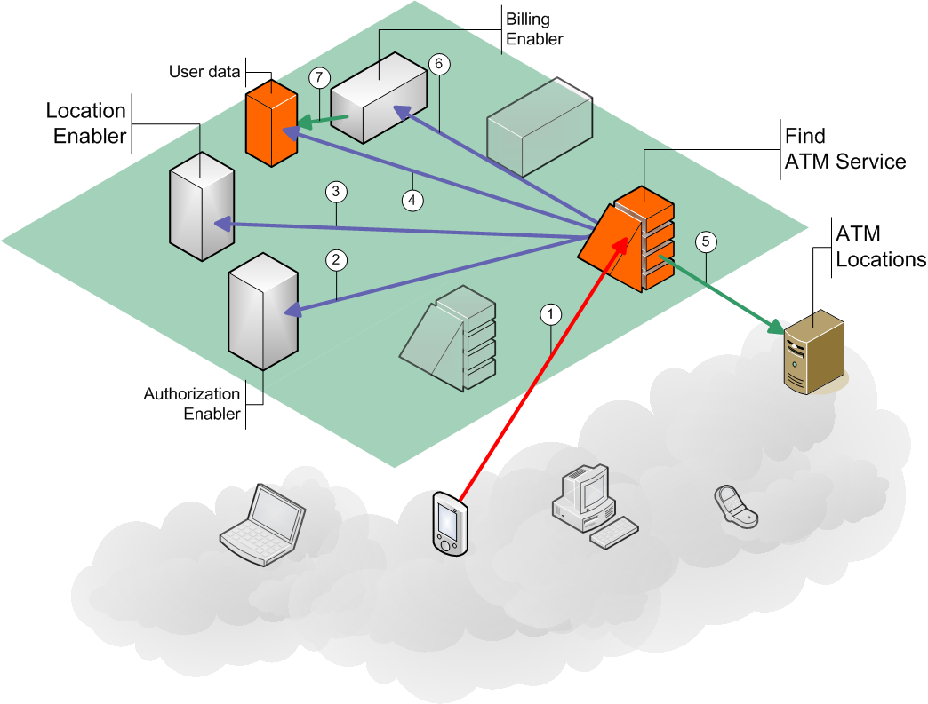
Figure 3: Find nearest ATM

- The client app initiates the service request by sending a message to the operator’s Find ATM Service.
- The Find ATM Service communicates with the Authorization enabler to see if the subscriber is allowed to use this service.
- The Find ATM Service gets the user’s location from the Location enabler (assuming this does not violate any privacy preferences or policies).
- The Find ATM Service queries the User data to find the name of the user’s preferred bank.
- The Find ATM Service sends a request, with the user’s location and preferred bank, to the external ATM Locations service (In this example the user’s identity is anonymous to the ATM Location service).
- The Find ATM Service sends information to the Billing enabler.
- The Billing enabler updates the User data.
As with the first scenario, the initial user request (red arrow) is unique to the operator’s mobile-service, the blue arrows and the behaviour of each enabler are expressed using specifications from Category 1, 2, and 3, and the Authorization enabler is from Category 4. Although the User data has a proprietary interface (green arrow as in the previous example), in this scenario it also exposes an OMA defined interface (4) for accessing certain user data.
Although the interface to the ATM Locations service (5) is likely to be based on Web services, it is shown as a green arrow because it will not be an OMA-defined interface.
    - Scenario-2b – Find nearest ATM (using 3rd party location enabler)
Customer uses operator provided mobile-service to find the nearest ATM for MyBank. It is assumed that the user has already been authenticated on the operator’s network. See Figure 4 below.

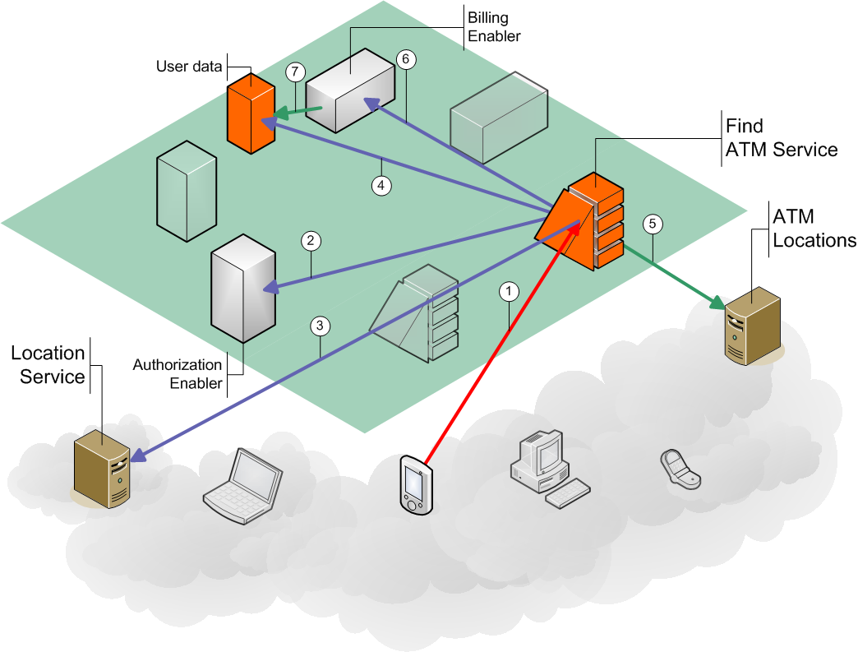
Figure 4: Find nearest ATM (using 3rd party location enabler)

- The client app initiates the service request by sending a message to the operator’s Find ATM Service.
- The Find ATM Service communicates with the Authorization enabler to see if the subscriber is allowed to use this service.
- The Find ATM Service gets the user’s location from the external Location Service (assuming this does not violate any privacy preferences or policies).
- The Find ATM Service queries the User data to find the name of the user’s preferred bank.
- The Find ATM Service sends a request, with the user’s location and preferred bank, to the external ATM Locations service (In this example the user’s identity is anonymous to the ATM Location service).
- The Find ATM Service sends information to the Billing enabler.
- The Billing enabler updates the User data.
This example is identical to the previous one except for step #3 where the location data is provided by an external Location Service. Since, in this example, the external Location Service is based on the same Location Enabler Release(s) as the internal enabler, the Find ATM Service can interact with the external enabler as easily as the internal one.
    - Scenario 3 – Operator provided billing
Customer purchases online content from a 3rd party provider and pays for it using mobile account. Although the user is already authenticated on the operator’s network, the user does not communicate with the operator directly during this transaction. The Online Content provider contacts the Payment Service on the user’s behalf. The user must provide the content provider with an ID, which the content provider can then pass to the Payment Service to authenticate the subscriber and authorize the billing. See Figure 5 below.

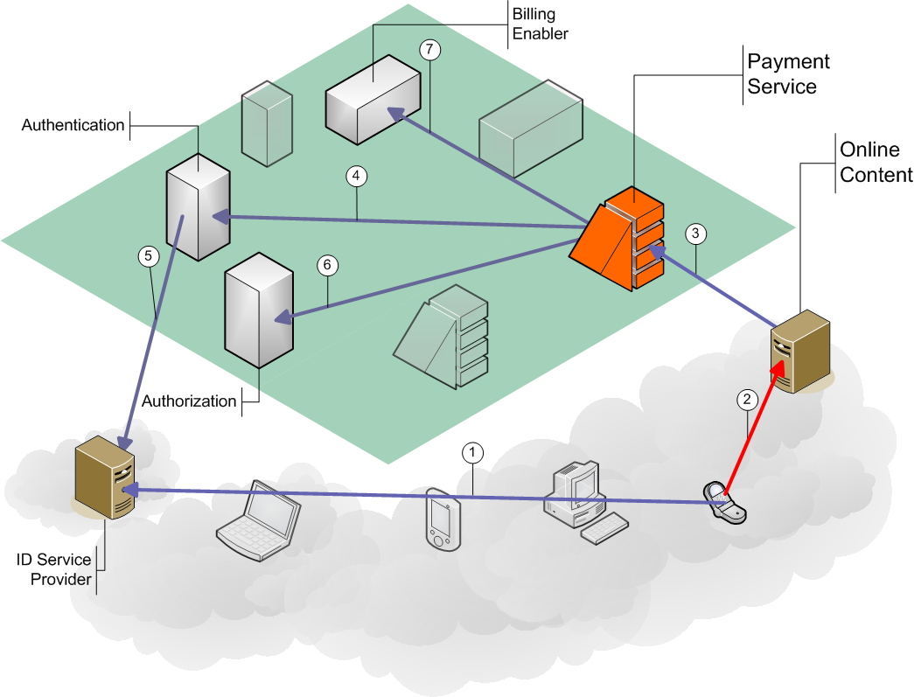
Figure 5: Operator provided billing

- The user has selected the content and wishes to pay for it. Before initiating the purchase transaction with the Online Content provider the client application must get an ID from the ID Service Provider. As noted earlier, the need for the ID, the discovery of, and binding to, the ID provider’s interface and the location of the ID provider’s service interface are generally addressed before the invocation of the service.
- The client application sends the purchase request, including the ID, to the Online Content service..
- The content provider sends details of the purchase request, including the user provided ID, to the operator’s Payment Service.
- The Payment Service sends the ID to the Authentication enabler.
- The Authentication enabler sends the ID to the ID Service Provider for validation.
- The Payment Service communicates with the Authorization enabler to see if the subscriber is allowed to use this service.
- The Payment Service sends a message to the Billing enabler.
The Authentication enabler and the ID Service Provider add new control functions to the system and so are included in Category 4. It should be noted that the Authentication enabler is entirely in the domain of the operator while the ID Service Provider is not in the same domain as the user, the content provider or the operator.
  - References
- Definition taken from recent thread on TP discussion list (http://mail.openmobilealliance.org/scripts/wa.exe?A2=ind0308&L=oma-plenary&O=A&P=16467).
- OMA-MWS-2003-0104-OWSF-Spec-20030818-D (http://mail.openmobilealliance.org/scripts/wa.exe?A2=ind0308&L=oma-mws&O=A&P=2408)
- Derived from W3C Web Services Glossary 8 August 2003 Working Draft (http://www.w3.org/TR/2003/WD-ws-gloss-20030808/) using the definitions for “service” (http://www.w3.org/TR/2003/WD-ws-gloss-20030808#service) and “component” (http://www.w3.org/TR/2003/WD-ws-gloss-20030808/#component)
- http://www.ws-i.org/Profiles/Basic/2003-08/BasicProfile-1.0a.htm
- http://www.oasis-open.org/committees/uddi-spec/doc/tcspecs.htm#uddiv2
- http://www.oasis-open.org/committees/download.php/3282/WSS-SOAPMessageSecurity-17-082703.pdf
- http://msdn.microsoft.com/ws/2002/12/Policy/
- http://msdn.microsoft.com/ws/2003/03/ws-reliablemessaging/
- http://msdn.microsoft.com/ws/2002/08/wstx/
- http://www.w3.org/TR/xkms2/
- Intellectual Property Rights Considerations
N/A
- Recommendation
It is recommended that this document, and specifically the four categories, be used as the basis for on-going discussions about the definition and use of Web services within OMA.

